Student’s Name Class

PA Physical Education Standard (10.4.6 A): Identify and engage in moderate to vigorous activities that contribute to physical fitness and health.
_ __ __ __ __ __ __ __ __ __ __ __ __ __ __ __ __ __ __ __ __ __ __ __ __ __ __ __ _

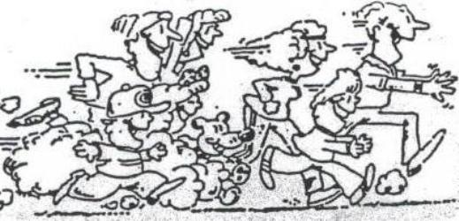
All students: Place an “X” in the box every day you
work out (at least 12 activities).

Return your calendar to Mr. Boronyak during the month of November for bonus points.

Parents: Encourage your child to be physically active. Please sign the calendar indicating that your child has completed the activities.

Sunday | Monday | Tuesday | Wednesday | Thursday | Friday | Saturday
Play catch with a family member or a friend. | Get rolling!  skate or ride  a bike. | You’re it!  Play your favorite  tag game. | Dribble a ball  200 times. | Take a walk with your family. | Play an outside game with your friends. | It’s  your Choice! Do something active!
Ride your bike, rollerblade, or walk. | Do push-ups &  crunches at least 3 times throughout the day | Play a game outside with your family☺ | Go fly a kite! | Be a soccer player, Kick a ball 20 times | Play Ball!  Practice your big league throw and catch. | TV commercial breaks…do 10 abdominal crunches
Help Rake Leaves. | Throw and catch a frisbee | Play a game of wiffleball, baseball, or softball. | Dance to a song  on the radio | Hop..skip..jump!  Skip rope for 10 minutes | How low can you go?  Limbo under a broom handle | Free Day!  You choose an activity to do
Play some football. | Shoot hoops with a friend or family member. | Can you beat your parents in a Backwards Run race! | Play a game outside for 30 minutes. | Jump to it!  Do 100 jumping jacks | Take a friend or a pet for a walk. | Play some sport.
Make your own obstacle course. | Scavenger hunt/geocach or nature hike with your family | Play football or catch outside | Go for a jog. | Go for a walk with a parent | Show your parents how you take your pulse | Play Hop Scotch!

Yes my son/daughter has completed at least 12 healthy activities ______ .
Parent / Guardian Signature

